ASSIGNMENT 26

Name : Akanksha Joshi

Roll No : B038

Batch : 3

Div : BTech CS B

--------------------------------------------------------------------------------------------------------------------------

Q. Consider a scenario from ABC Training Institute. Given below are two Sets representing the names of students enrolled for a particular course.

java_course = (“John”,”Jack”,”Jill”,”Joe”)

python_course = (“Jake”,”John”,”Eric”,”Jill”)

Write a Python program to list the number of students enrolled for :

1. Python course
2. Java course only
3. Python course only
4. Both Java and Python course
5. Either Java or Python course but not both
6. Either Java or Python courses

Source Code

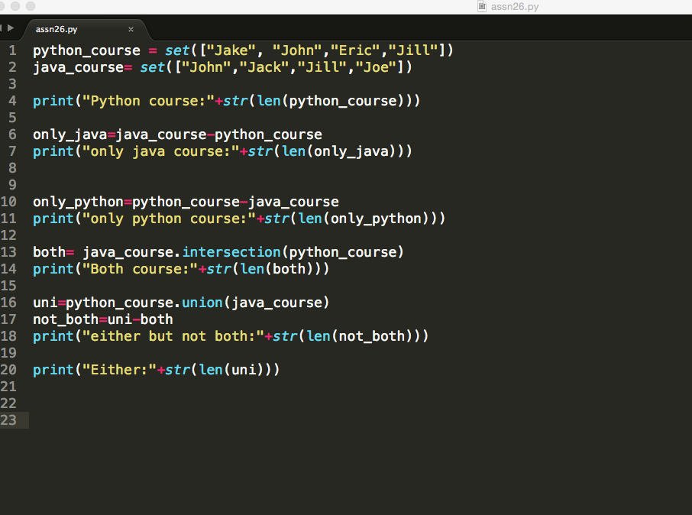

Output:

Python course:4

only java course:2

only python course:2

Both course:2

either but not both:4

Either:6